Delay
Q1.
Part1: The Texas Instrument company’s analog engineers are designing a CMOS 3- input NAND gate considering delay and power consumption. They have chosen $GaN$ semiconductor which has $μ_{n} = 3μ_{p}$.
They have fixed the width scaling factor $k_{n}= 2$ for NMOS transistors and want to meet equal fall and rise resistance. Later, they are informed that the NAND gate will drive a total load of three NOT gates and two OR gates.
Part 2: There is a RC tree network given below.
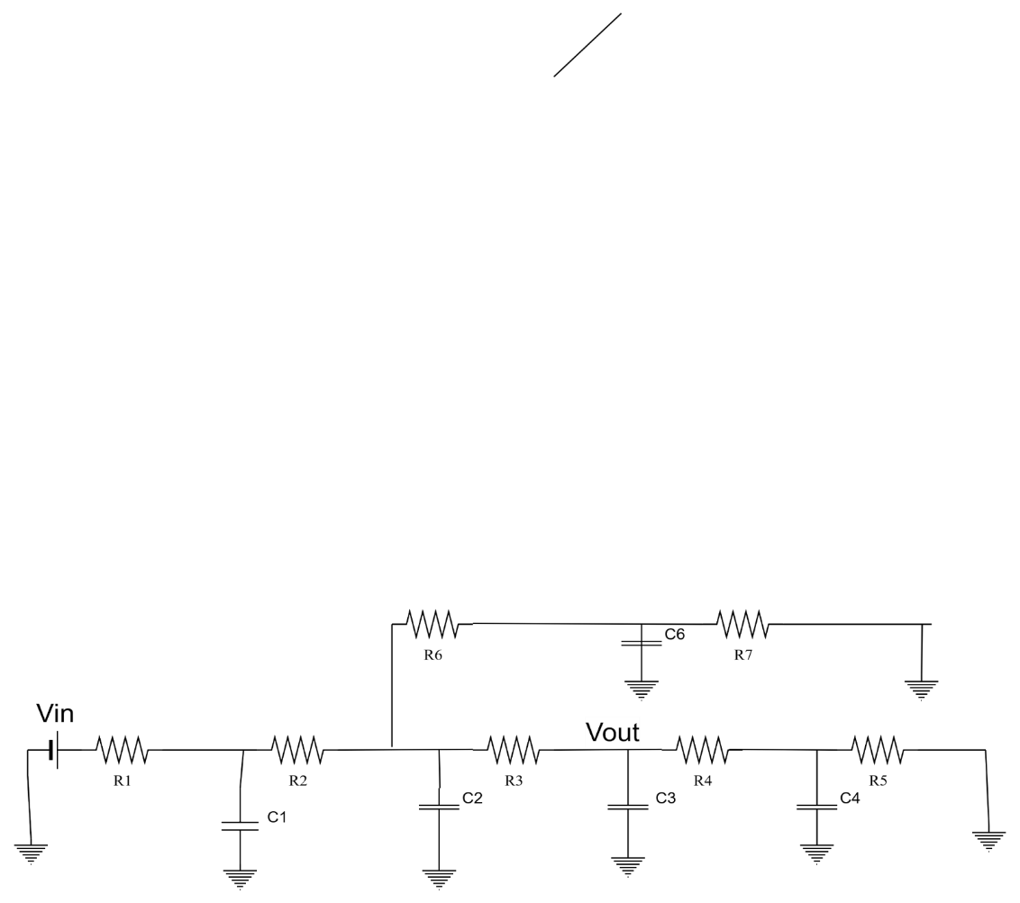
(a) | Find the width scaling factor for PMOS ($k_{p}$) to meet the rise and fall resistance specification. | [2]
(b) | Draw the RC equivalent circuit of the NAND gate considering the loads are not connected. Use the Elmore delay model to find the expressions for $t_{cdr}, t_{pdr}, t_{cdf}$, and$t_{pdf}$. | [7]
(c) | If each NOT gate and OR gate load contributes $3C, 5C$ unit capacitance respectively, then after connecting the load estimate how many times slower the NAND gate output will operate compared to load disconnected condition considering propagation delay rising for both cases. | [3]
(d) | In Part2, if the $R_{1} , R_{2}, R_{3} , R_{4}$and $R_{6}$ path is on then estimate the worst case rising delay using Elmore delay model associated with $V_{in}$ to be propagated to $V_{out}$. | [3]

